School of Engineering and Digital Sciences
Master of Engineering Management program
Big Data and Information Management (EMEM 539)



Fall 2025 - Group Project Report

Adil Kurmantas
Balausa Ramatulla
Dias Nurmukhambetov 201845504
Miras Mels
Serikbolsyn Satov 201849753

Submission Date: 29 November 2025

Academic Year 2025-2026
Table of Contents

Section 1 - Big Data Types, IIM and Analytics for BMW 2
1.1. Uses, Pros and Cons for different Big Data types 2
1.2 Moving From Records Management to Intelligent Information Management 3
1.3 Comparative Analysis of Analytics Types & Most Critical for BMW 3
Section 2 - Big Data Framework, Processing and ELT vs ETL 4
2.1 Role of Tools at Each Big Data Framework Stage 4
2.2 Batch vs Real-Time Processing in BMW’s Context 5
2.3 ELT vs ETL for BMW’s Big Data Transformation 5
Section 3 - Python Data types, Sequences, and Variable Naming (BMW Case study) 6
3.1 How three python data types handle BMW data 6
3.2 Comparison Python sequence types 6
3.3 Ten valid Python variables with correct data types 6
Section 4. 8
4.1. Numbers & functions 8
4.2. Strings 8
4.3. Decisions 9
Section 5: Visualization tasks 10
5.1. Visualization Task 1 10
Figure 5.1. A comparison visualisation of a key metric across categories 10
Figure 5.2. A distribution visualisation of the same metric 10
5.2. Visualization Task 2 11
Figure 5.3. A comparison visualisation of average values across segments for the latest period 11
Figure 5.4. A trend visualisation of the metric over time 11
5.3. Visualization Task 3 12
Figure 5.5. A relationship visualisation between two numeric variables 12
Figure 5.6. A comparison visualisation comparing the metric between at least two groups 12
Section 6. 14
6.1. Model A (Linear Regression) Results (Task 1) 14
6.2. Model B (Random Forest) Comparison (Tasks 2 & 3) 15
6.3 Comparison and conclusion 15
Section 7. 16
Section 8. 18
8.1. Decision tree Classification 18
Figure 8.1. Decision tree with target variable “Sales Volume” 18
8.2. Decision tree results 19
Figure 8.2.1. Accuracy of the tree without “Sales Volume” and “Mileage” 19
Figure 8.2.2. Decision tree without “Sales Volume” and “Mileage” 19
8.3. Tracking decision tree features 20

Section 1 - Big Data Types, IIM and Analytics for BMW

1.1. Uses, Pros and Cons for different Big Data types
Structured Data | Uses for BMW | Demand forecasting, pricing analysis, regional comparisons, fleet management
 | Pros | Easily processed by databases; high accuracy; ideal for dashboards and ML models
 | Cons | Limited context (cannot explain customer sentiment or dealer interactions)
 | Examples | Year, Model, Region, Price_USD, Sales_Volume, Engine_Size_L
Semi-structured Data | Uses for BMW | Mapping online intent to actual purchases, monitoring leads, evaluating marketing campaigns
 | Pros | Flexible schema; supports rapid evolution of digital products
 | Cons | Requires parsing; heterogeneous structures increase processing complexity
 | Examples | Website configurator logs, CRM exports, JSON/XML files from BMW.com
Unstructured Data | Uses for BMW | Sentiment analysis, quality monitoring, early detection of product issues
 | Pros | Provides contextual richness and qualitative understanding
 | Cons | Noisy and difficult to analyse; requires NLP/CV tools; higher storage and compute needs
 | Examples | Customer reviews, dealership emails, social media posts, images, videos
Table 1.1 Different Big Data types

1.2 Moving From Records Management to Intelligent Information Management

Stage | Key characteristics | BMW Examples
Records Management (RM) | - Focus on storing sales records  - Siloed dealer systems  - Manual reporting via Excel  - Limited Analytics | - Local BMW spreadsheets  - No unified view of global sales  - Monthly summaries only
Enterprise Information Management (EIM) | - Centralised data warehouse  - Standardised KPI’s and definitions  - Batch data ingestion  - Improved governance and data quality | - Global sales database (2010-2024)  - Unified model/region codes  - Regular ETL updates for dashboards
Intelligent Information Management | - Integrated structured and unstructured data  - Automated pipelines and real-time dashboards  - Predictive analytics and ML  - Close connection to business decisions | - Predicting future sales volumes  - AI-driven pricing and stock optimisations  - Linking online behaviour to final sales
Table 1.2 Transition from RM to IIM

1.3 Comparative Analysis of Analytics Types & Most Critical for BMW
Table 1.3 Comparative Analysis of Analytics Types & Most Critical for BMW
 | Descriptive Analytics | Diagnostic Analytics | Predictive Analytics | Prescriptive Analytics
Answers | “What happened?” | “Why did it happen?” | “What will happen next?” | “What should we do?”
Examples | Annual sales trends; top-selling models; regional performance | Lower sales for Diesel engines explained by regional trends; higher classifications linked to low milage | Predicting Sales_Classification, forecasting demand by Model and Region, estimating pricing elasticity | Recommending optimal stock levels per region; suggesting promotional strategies for low-performing segments
Role | Foundational reporting for executives | Root-cause analysis for performance variance | Critical for production planning, inventory optimization and distribution | Converts insights into recommended actions
Predictive analytics type is the most critical. The dataset contains rich features as price, mileage, region, fuel type that directly support forecasting future sale trends and model popularity, which is very important for BMW’s operations, supply chain and strategic planning.

Section 2 - Big Data Framework, Processing and ELT vs ETL

2.1 Role of Tools at Each Big Data Framework Stage
BMW’s data pipeline aligns with the Big Data Framework, consisting of ingestion, storage, processing, analytics, and visualisation. The tools used in our project replicate this framework at a smaller scale.
Data Ingestion | Tools | Pandas (read_csv)
 | Role | Loads BMW’s raw structured sales data into Python
 | Real BMW equivalent | API’s, dealership systems, CRM systems
Data Storage | Tools | CSV file (simplified representation of a data warehouse)
 | Role | Provides a consistent, centralized dataset
 | Real BMW equivalent | Cloud data lakes, enterprise warehouses
Data processing and integration | Tools | Pandas, Python
 | Role | Data cleaning, transformation. Encoding categorical variables, checking data types
Analytics and modelling | Tools | NumPy, scikit-learn, Pandas
 | Role | Descriptive analytics: summary statistics, grouping, aggregating  Predictive analytics: Linear Regression, Random Forest, KNN  Performance evaluation: R’2, MAE
Visualization and Decision support | Tools | Matplotlib
 | Role | Producing bar charts, line graphs, histograms to communicate insights clearly
Table 2.1 Role of Tools at Each Big Data Framework Stage

2.2 Batch vs Real-Time Processing in BMW’s Context
Table 2.2 Batch vs Real-Time Processing in BMW’s Context
Batch Processing (used in our project) |  | Real-time Processing (IIM stage)
Processes large volumes of historical data at once  Suitable for annual trends, model performance, price evolution  Our dataset (2010-2024) fits batch processing perfectly |  | Processes data continuously as events occer  BMW needs real-time analytics for:  - Online vehicle configurator activity  - Inventory updates by region  - Dynamic pricing
Advantages | Uses for BMW | Advantages | Challenges
Simpler, stable, efficient | Monthly financial reporting, annual production planning | Instant decision-making | Requires streaming and automated pipelines

2.3 ELT vs ETL for BMW’s Big Data Transformation
Traditional ETL | Modern ELT
- Transformation happens before loading  - Limits flexibility  - Risk of losing important raw details | - Raw data is first loaded into a cloud warehouse  - Transformations occurs on-demand  - Allows multiple teams to run different queries on the same data
Why ELT is better for BMW and our dataset
- Preserves full granularity (e.g., mileage, engine size, exact price)
- Enables feature engineering for predictive modelling
- Supports BI tools, dashboards and near real-time analysis
- Scales better for global sales volume
Table 2.3 ELT vs ETL for BMW’s Big Data Transformation

Section 3 - Python Data types, Sequences, and Variable Naming (BMW Case study)

3.1 How three python data types handle BMW data
Integer (int) | Used for: | Year, Sales_Volume, Mileage_KM
 | Role: | Counting units, aggregations, segmentation
Float (float) | Used for: | Engine_Size_L, Price_USD
 | Role: | Precision in pricing, engine comparison, forecasting inputs
String (str) | Used for: | Model, Region, Fuel_Type, Transmission, Sales_Classification
 | Role: | Categorisation, grouping, labelling models and markets
Table 3.1 Python Data types

3.2 Comparison Python sequence types
Lists help analyse model groups, tuples preserve dataset constraints, and ranges simplify time-series analysis.
List | Tuple | Range
Mutable and ordered | - Immutable  - Good for fixed dataset boundaries or “locked” attributes | Sequence of integers, idea for loops
Example: bmw_models = ["3 Series", "X5", "i8"] | Example: dataset_range = (2010, 2024) | Example: years = range(2010, 2025)

Table 3.2 Comparison Python sequence types

3.3 Ten valid Python variables with correct data types
bmw_model = "5 Series"
region_name = "Asia"
year_produced = 2016
unit_sold = 8300
engine_size_l = 3.5
price_usd = 98740.0
top_regions = ["Europe", "Asia", "North America"]
first_record = ("5 Series", 2016, 8300)
year_sales_map = {2016: 8300, 2017: 3428, 2018: 6994}
is_luxury_model = True

These variables follow Python rules (no digits at start, no special characters, not keywords) and match BMW’s real-world dataset features.

Section 4.

4.1. Numbers & functions
The objective was to calculate the Performance Premium (Price / Engine Size) for BMW models in the highly competitive Europe, 2024 market segment. Due to the dataset's synthetic nature, the data was consolidated by configuration, and the classification thresholds for Low/Medium/High were dynamically calculated using quartiles (Q1 and Q3) to ensure meaningful relative performance labeling. This dynamic approach guaranteed that the top 25% of models were correctly labeled "High" for their market. The final analysis successfully identified the X3, 3 Series, and 5 Series as the leaders in Performance Premium.
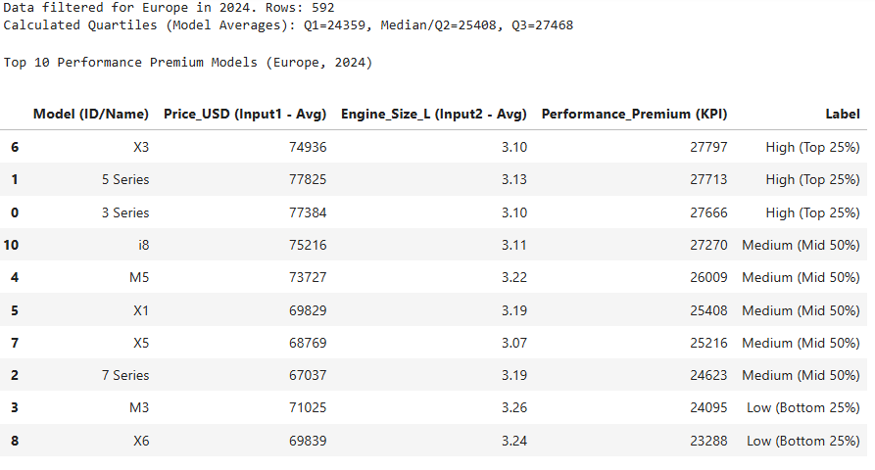Figure 4.1 Code output in a form of a table

4.2. Strings
We focused on segmenting the Model column after standardizing the text by stripping whitespace and applying lowercase transformations to ensure accurate filtering. We created three distinct cohorts—X-models (SUV), M-models (Performance), and Series-models (Sedan)—using simple string checks (starts with 'x', starts with 'm', contains 'series') to categorize the primary vehicle types. The final table successfully illustrates the count and examples for each vehicle segment, validating the straightforward string-based segmentation logic we employed.
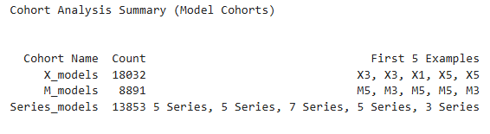
Figure 4.2 Code output of segmentation by naming structure

4.3. Decisions
We initiated this final task by filtering the data to the Asia, 2024 market and established a strict $70,000 budget for a model. To create the reliable purchase viability flag, we resolved a critical bug by switching the price check from the model's average price to its minimum available price against the budget. We calculated the market's dynamic Q1 KPI threshold and combined three key consumer conditions (Color, Min Price, Avg KPI) into a single Meets All Criteria flag. The use of a dynamic Q1 threshold ensured that the KPI requirement correctly identified models with at least medium Performance Premium relative to their Asian peers. Finally, we generated the model count table and a top-ten snippet of individual sales rows that successfully met all these combined criteria.
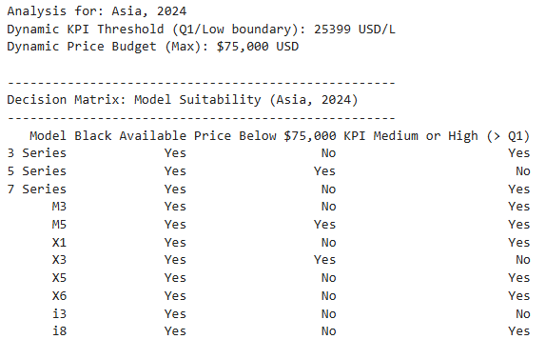
Figure 4.3 Decision matrix output based on the chosen criteria

Section 5: Visualization tasks

5.1. Visualization Task 1

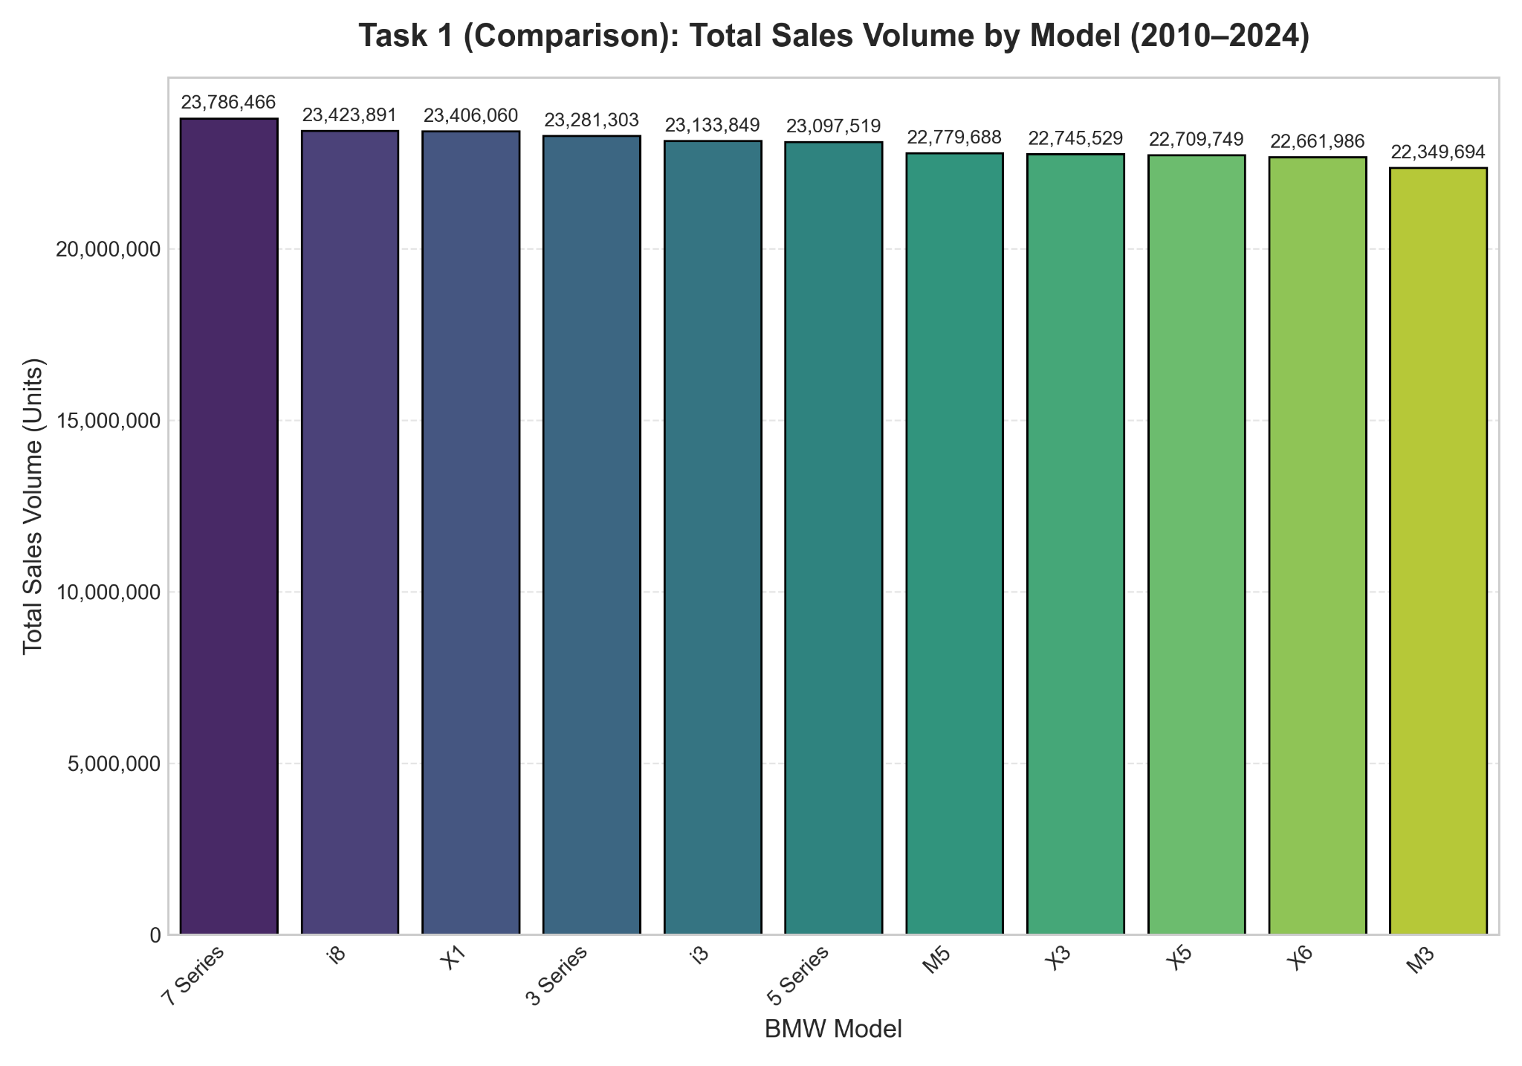

Figure 5.1. A comparison visualisation of a key metric across categories

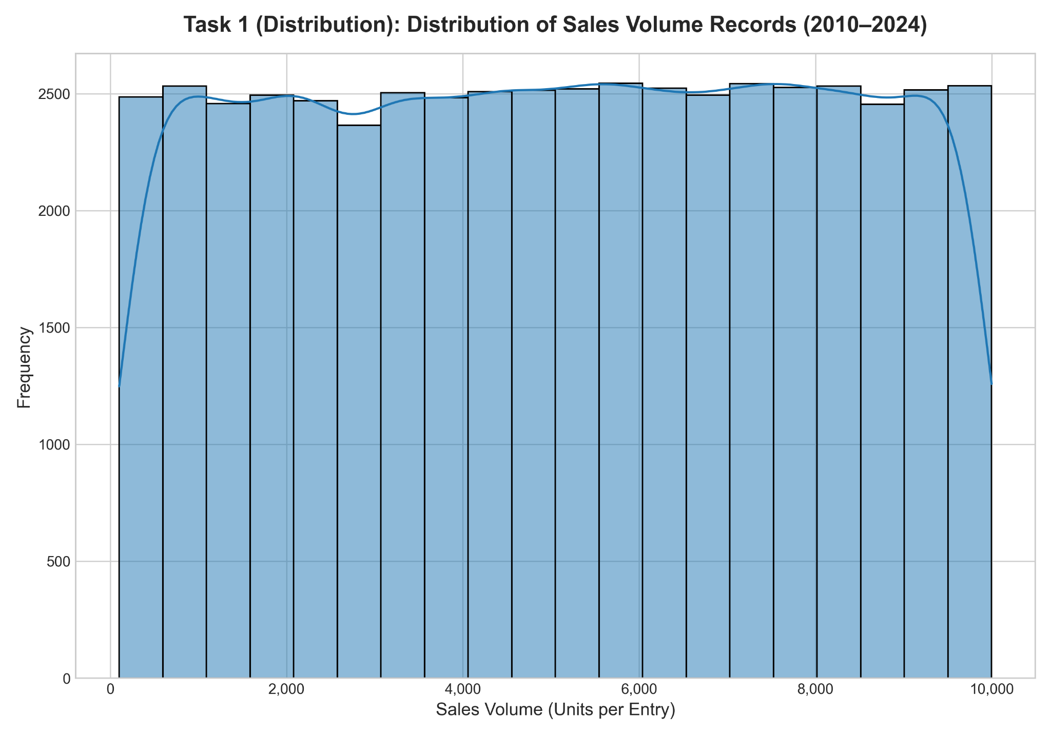

Figure 5.2. A distribution visualisation of the same metric

For task 1, two graphs were drawn. The bar chart for a metric across key categories and histogram for a single metric. As it can be seen from the first graph, total sales across different models of BMW is more or less the same, within the range of 22 - 24 million units. With regards to the second graph, the shape is pretty uniform, a skewness cannot be noticed. A real useful data cannot be really retrieved from this graph.

5.2. Visualization Task 2

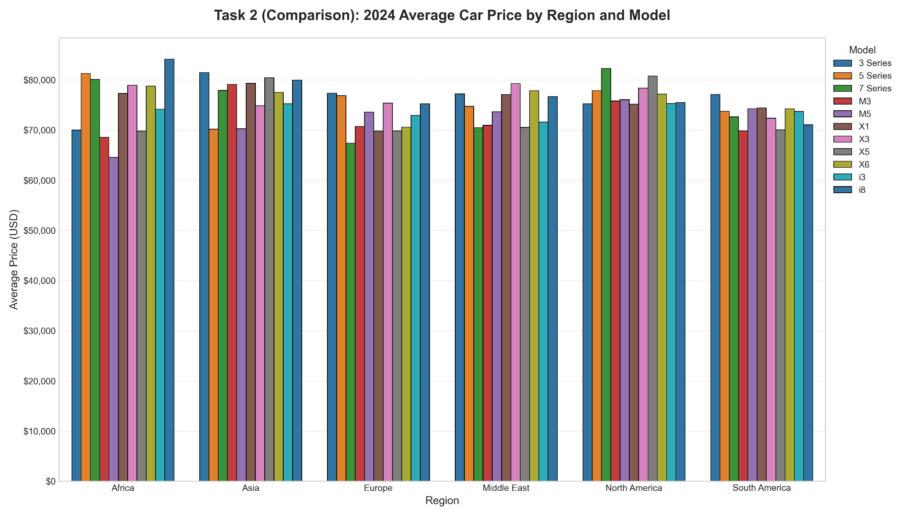

Figure 5.3. A comparison visualisation of average values across segments for the latest period

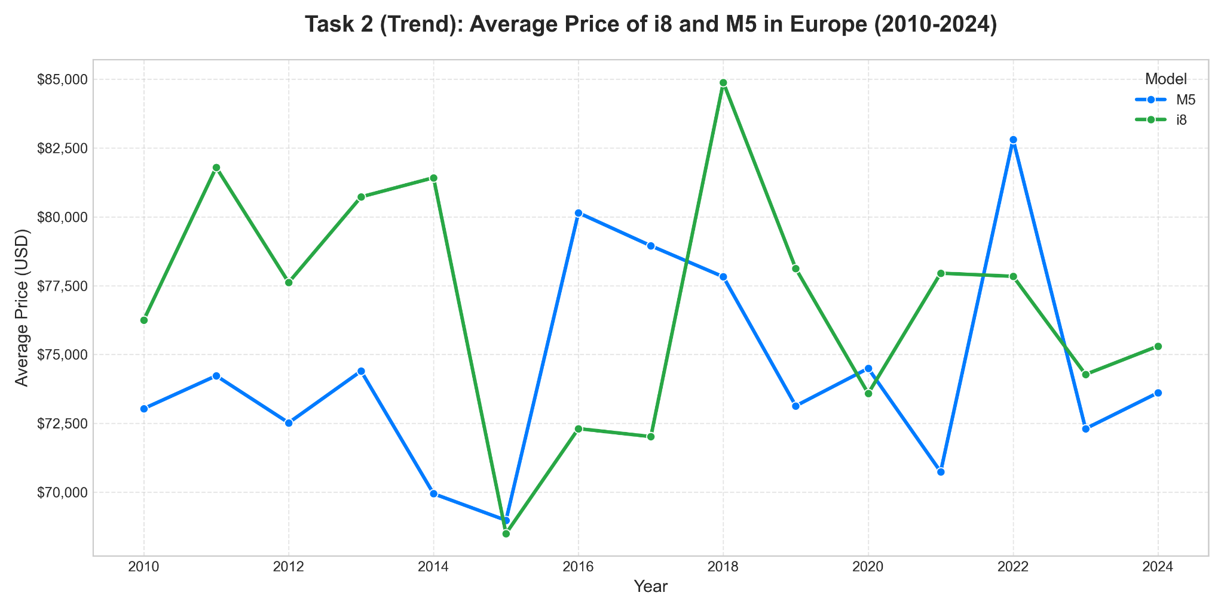

Figure 5.4. A trend visualisation of the metric over time

For trend analysis, a line graph was chosen. This is the best type of graph to track the price of the model over time. It shows ups and downs of the price, so can be really useful for future analysis. A selection of bar charts can be justified with the fact that it perfectly shows the comparison of average price of BMW models in 2024 across 6 different regions. It is interesting that the highest average price and lowest average price for BMW models across all regions is in the Africa region.

5.3. Visualization Task 3

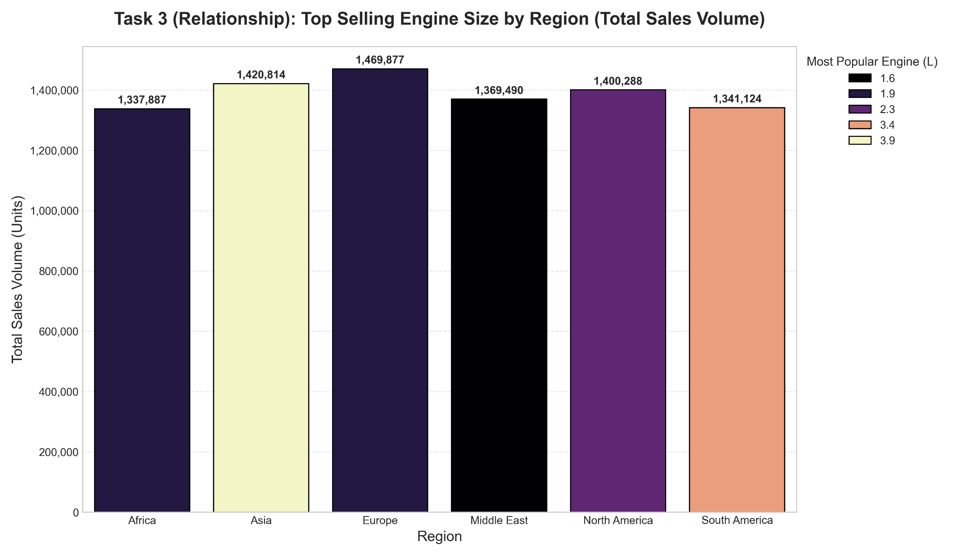

Figure 5.5. A relationship visualisation between two numeric variables

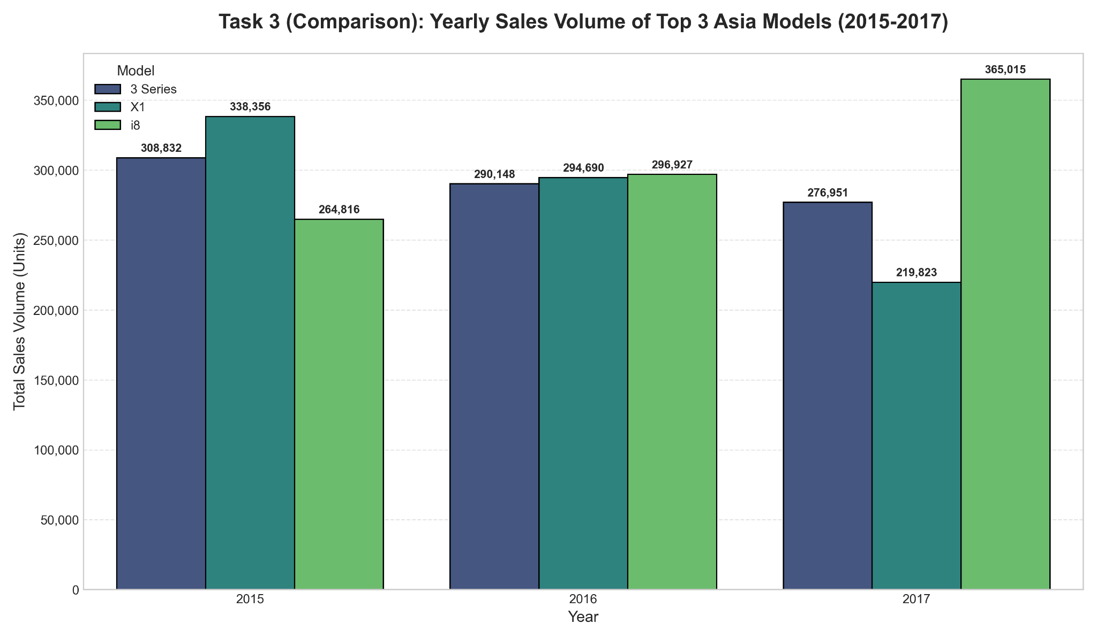

Figure 5.6. A comparison visualisation comparing the metric between at least two groups
Figure 5.5 showcases the overall sales volume for the most popular engine size in various regions of the world. The bar chart representation used in the figure is appropriate for the data because it is able to effectively demonstrate the variance in the levels of the sales volumes for the regions. Also, the color legend helps in the instant determination of the most popular engine size in the market.

Figure 5.6 illustrates the annual sales volumes for the top three most sought-after BMW models in the Asian market from 2015 through 2017. Such a grouped bar graph allows for the comparison of the performance of different models in the same year. Additionally, the graph allows for the determination of the models that experienced an increase or decline in their popularity during the period.

Section 6.

6.1. Model A (Linear Regression) Results (Task 1)
The prediction task was to build a regression model based on the dataset. To start with, our team decided to predict the average price in thousands of dollars of hybrid and electric car models in Asia. For model A, we trained a Linear regression model. We used an 80/20 split - using average prices in years 2010-2021 for training, and data from years 2021-2024 to test our model. The Linear regression model has no other parameters to set up, so we proceeded with the training.
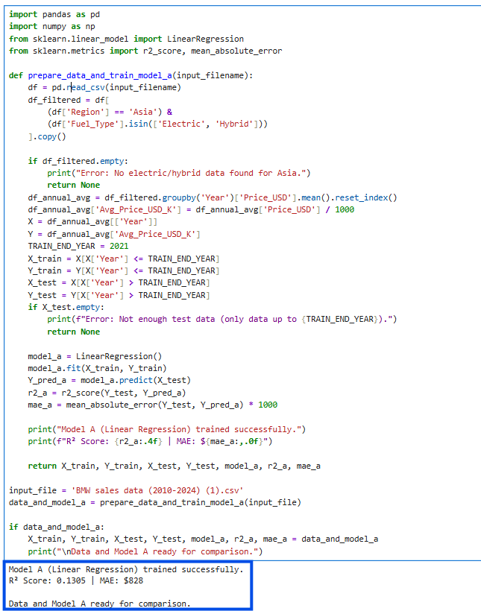
Figure 6.1. Code output of linear regression model training.
To benchmark the model accuracy, we used R-squared and Mean Absolute Error(MAE) methods. R-squared displays a more accurate representation of the model's performance with a benchmark threshold score of 0, while MAE gives us a general understanding of the deviation in dollars.
In the case of the Model A, the R-square score is slightly higher than 0, meaning that it is technically better than guessing future average prices based on the average of past years. However realistically speaking, it is not a great result, we will discuss it in the further part.

6.2. Model B (Random Forest) Comparison (Tasks 2 & 3)
Model B (Random Forest Regressor) was chosen to capture potential non-linear shifts in EV market pricing. The model’s accuracy is also measured by the R² score and Mean Absolute Error (MAE). While training the Random Forest Regressor, we noticed that changing the number of estimators affects the prediction accuracy. We manually implemented a sort of a binary search in order to indicate the perfect number of estimators. It turned out to be 58, meaning that anything higher or lower than that would result in a more inaccurate prediction.
Unfortunately, at the most efficient level, the model B still underperformed, resulting in R-square score being lesser than zero, and MAE of $916.

6.3 Comparison and conclusion
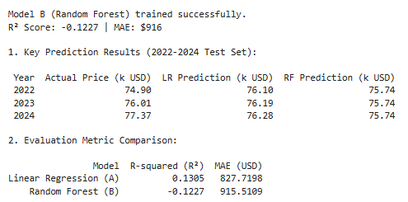
Figure 6.2. Code output of Model B’s performance and comparison to the Model A.

We would choose Linear Regression (Model A). Although both models performed poorly with R² scores near zero (indicating the price trend is too volatile for simple prediction), Model A demonstrated a lower Mean Absolute Error 828$ USD) than Model B 1,010$ USD). Model A is also much simpler and faster to train, providing a slightly better prediction with fewer practical costs.
Sadly, in real life, we shall not ignore such poor performance, and try to approach the problem in a more trustworthy manner. We relate the model error to data scarcity and rough generalization of the key indicator. Predicting an average price for all the car models that use electric and hybrid motors is a pretty vague prediction, because the target value itself includes a mass variety of actual car models that may have their own market specific sales performance trends throughout the years. So the core issue here is the problem composition resulting in a too-broad target indicator and scarce dataset.

Section 7.
This section is about using the prediction of a BMW car's sales performance to be classified as either "High" or "Low". The first step was to preprocess the data, which included encoding categorical variables such as Region and Color and ultimately scaling the numerical ones before training a K-Nearest Neighbors (KNN) model. We made use of a conventional 80/20 train-test split in order to be able to assess the model's performance on the data that it had not seen before.

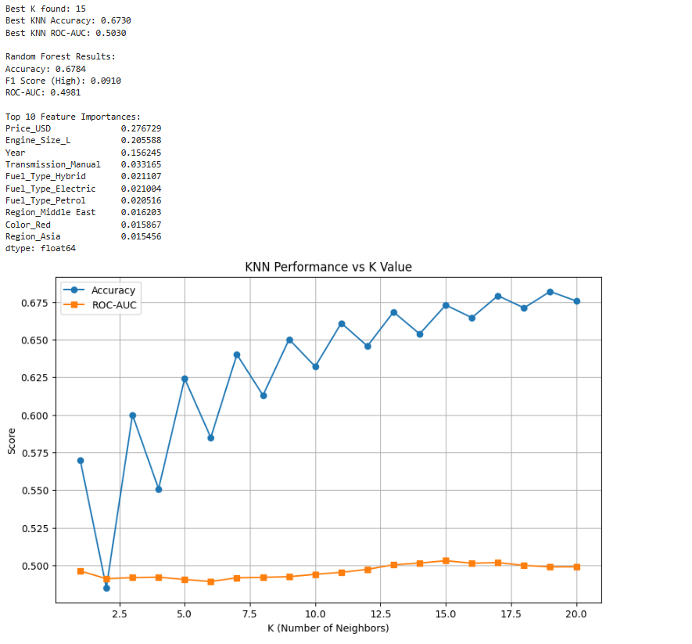
Figure 7.1 Code output
We recorded the prediction results by calculating three specific metrics on the test set: Accuracy, F1 Score, and ROC-AUC. These values were stored in a structured results table to provide a clear summary of performance. This allowed us to assess not just how often the model was right, but how well it handled the specific balance between the "High" and "Low" classes.
The biggest challenge was that the data were synthetic, and the relationships between the features and the sales figures were weak and unrealistic. We also had to be sure to exclude the Sales_Volume column to prevent "data leakage," since this column directly contains the answer our model is trying to predict. Removing this column made the model learn from truly informative features like price and engine size.
The Sales_Classification column is the label we’re trying to predict. Following the assignment, we set things up so that all the input features go on the left, and Sales_Classification sits in the last column on the right.Basically, the target variable here is whether a car’s sales are “High” or “Low.” That’s what we’re modeling. It depends on all the other features, like Price or Engine Size, and acts as the answer key for training our classifier.
We went the extra mile to train a Random Forest (RF) model to determine if the low scores were caused by the simplicity of the KNN algorithm or the quality of the data itself. Since the more powerful Random Forest model only performed marginally better, it confirmed that the issue lay with the weak
patterns in the synthetic data, validating that our KNN implementation was not at fault.While Random Forest looks better on the "Accuracy" scoreboard, it likely achieved this by being "lazy" and predicting the majority class. Neither model successfully "learned" the difference between High and Low sales, confirming that the synthetic data lacks strong predictive patterns.


Figure 7.2 KNN Performance depending on K Value
This plot shows a hyperparameter tuning experiment, where the number of neighbors K is varied from 1 to 20 to see its impact on the model's performance. The Accuracy (blue line) improves and then plateaus at around 67% as K increases, which might at first suggest that the model is learning to perform better. However, the ROC-AUC (the orange line) remains flat at 0.50, which is the score for random guessing, indicating that the model isn't improving at distinguishing between high and low sales. Rather, the rising accuracy actually suggests that with increasing $K$, this model stops trying to find informative patterns and simply predicts the majority class for nearly all the cars, thereby "gaming" the accuracy metric without solving the actual problem.
To further enhance this model, we could add external economic features such as "Interest Rates" or "GDP Growth," because sales of luxury cars tend to be highly sensitive to the wider economy. Also, specific product metrics like "Safety Ratings," "Marketing Spend per Region," or "Customer Satisfaction Scores" would probably give a much stronger predictive signal than basic attributes such as color or fuel type.

Section 8.

8.1. Decision tree Classification
The decision tree target variable is to classify the “Sales Classification” whether its “High” or “Low”. The majority of the data of 80% was used to train the decision tree (40000 data samples), while 20% was used for tests (10000 samples). The model which was used for the Decision tree is “DecisionTreeClassifier(criterion="gini", max_depth=5, min_samples_split=4, random_state=42)”. On the first run the primary variable for the classification of the decision was “Sales Volume”, during the first run of the model it was found that the Accuracy of classification was equal to 1.00. Indicating that the model correctly classified all of the test samples.

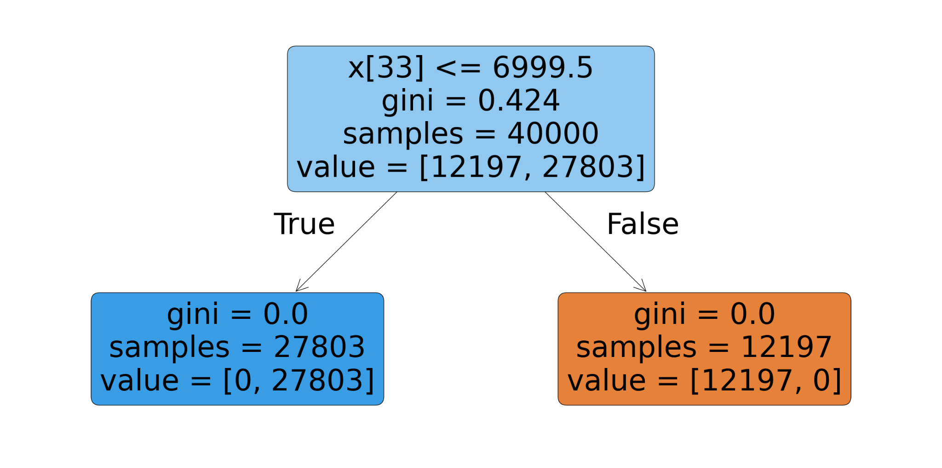

Figure 8.1. Decision tree with target variable “Sales Volume”

In the first run, where “Sales Volume” was a primary input variable, thus it created a target leakage, because the “Sales Classification” is directly related to the “Sales Volume” using a threshold. Therefore, the decision tree does not learn the relationship between car characteristics and sales performance to correctly classify the “Sales Classification”, the tree simply discovers the threshold, thus achieving a perfect performance, with F1-score of 1.0 on the test set. One of the major flows is mainly that the chosen data set is synthetic where the classification is directly derived from the “Volume”, thus in the next run the “Sales Volume” was removed from input variables. The Mileage was removed from the set to as it had no correlation to the price, from visual observation, thus it was decided to filter it out to have a better result.

8.2. Decision tree results
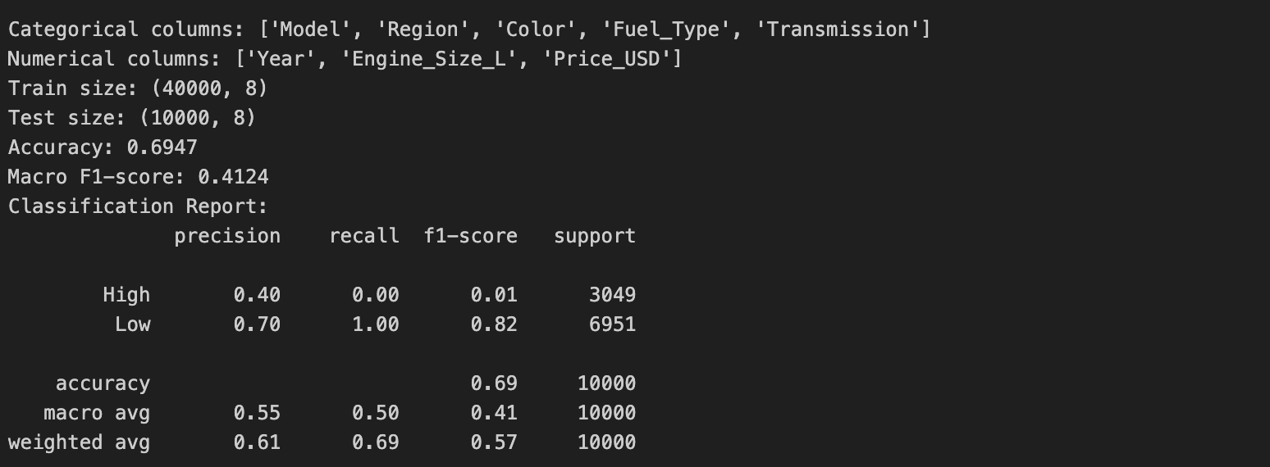

Figure 8.2.1. Accuracy of the tree without “Sales Volume” and “Mileage”

The results indicate that the model achieves overall accuracy of 0.69, thus showing that the tree predicts the correct classification of the sales around 69.5%. On the other hand, the classification report indicates that the tree correctly predicts all cases of “Low” sales classification with recall of 1.00 (it identified all low cases), while the “High” classification is fully missed with recall of 0.00 meaning that the model failed to identify the 3049 sales samples as “High”. This large gap results in a much lower macro F1-score of 0.4124, showing that performance is unequal between two classes. The result indicates that the decision tree is biased toward predicting the majority classes as “Low”, which is expected due to the imbalanced dataset, since there are more “Low” classes rather than “High”.
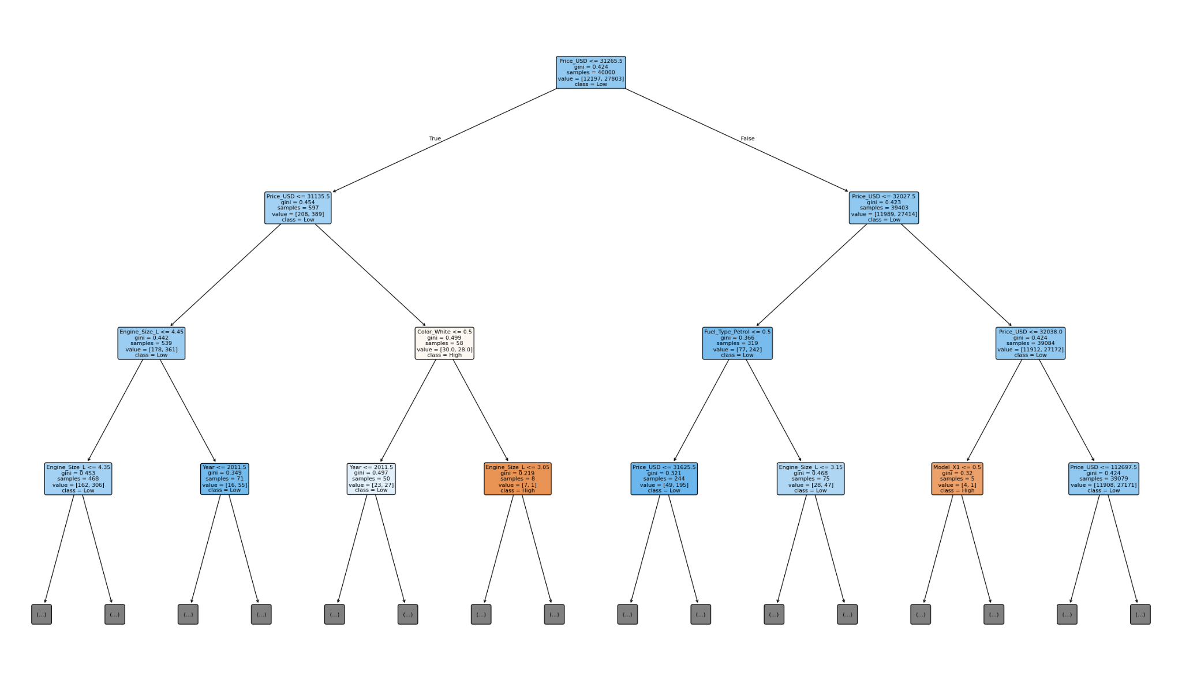

Figure 8.2.2. Decision tree without “Sales Volume” and “Mileage”

8.3. Tracking decision tree features
While the decision tree continues to divide, we can monitor feature importance through two methods: evaluating the splitting sequence from the tree plot or retrieving the calculated feature importance scores from scikit-learn, representing the importance of each feature to reduce the impurities across the entire tree.

In this case, observing the sequence of splitting features, such as Price_USD, Engine_Size_L, Model, at the top of the tree can provide us with the list of features that the model considers to be most influential for making classifications. This is especially important as it provides us with a key to understand relationships reflected from the actual data, pointing to those car features that drive the difference between high sales and low sales car classifications. It can provide us with a direction to develop new features, remove unnecessary dimensions, or even collect new data that can better illustrate less-populated patterns.

